1. Before Insertion

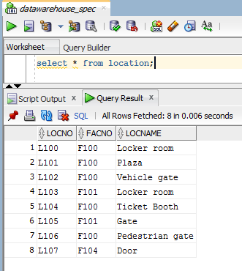

2. Insertion

INSERT INTO Location (LocNo, FacNo, LocName)

VALUES ('L108','F104','Locker Room');

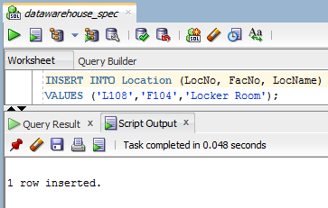

3. After Insertion

